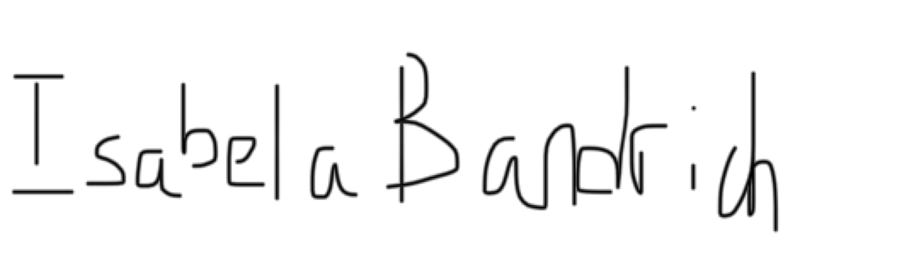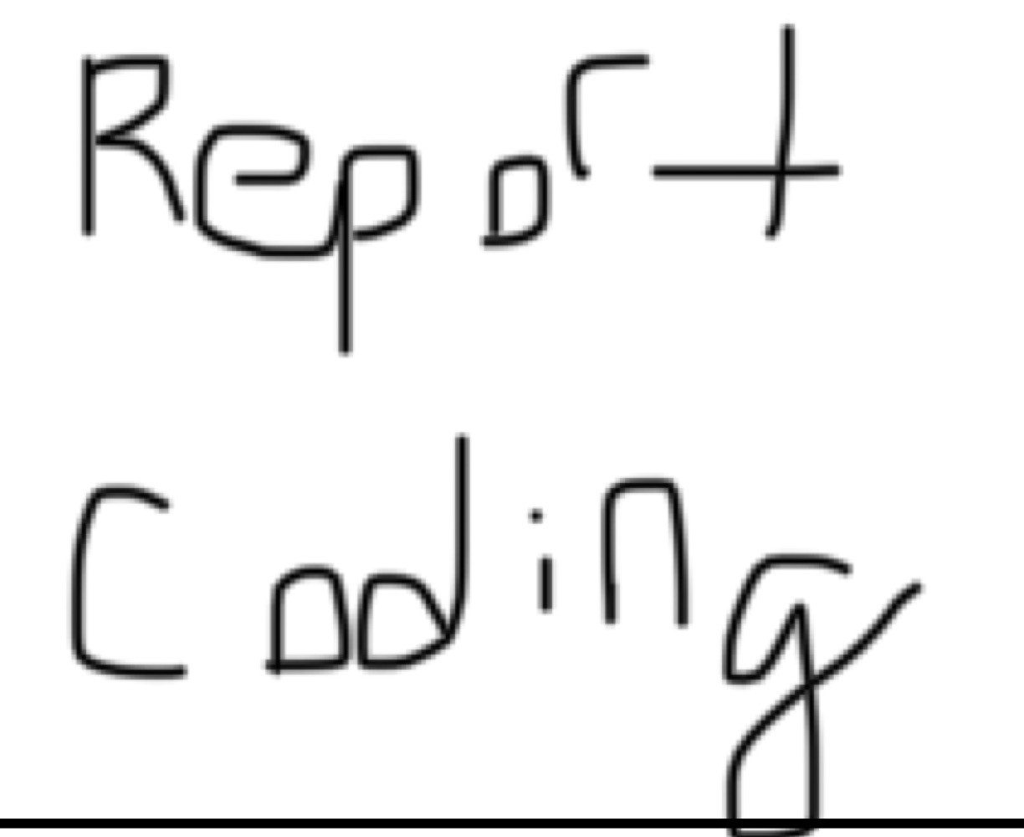

ECE414 Computer Organization and Design Lab Responsibility and Demonstration Sheet

|  |  |  |
| --- | --- | --- |
| Lab # |  |  |
| Lab Description |  | |

Lab Responsibility Assignment

|  |  |  |
| --- | --- | --- |
| Student Name | Responsibility | Signature |
|  |  |  |
|  |  |  |
|  |  |  |
|  |  |  |
|  |  |  |

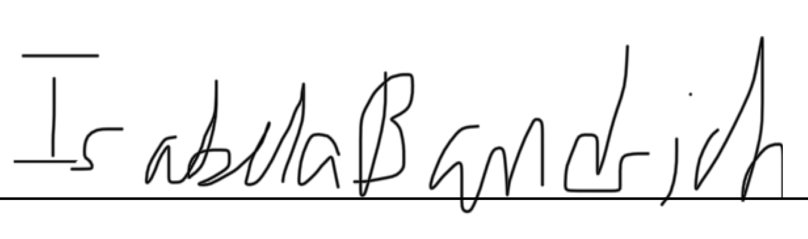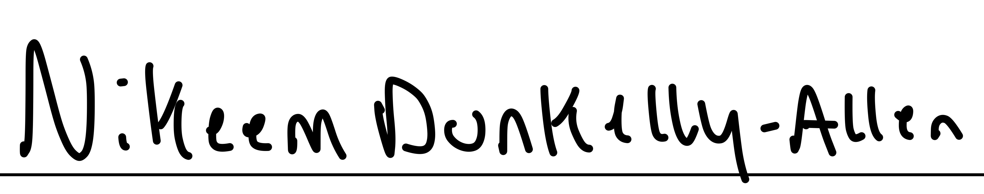Lab Demonstration

|  |  |
| --- | --- |
| Teaching Assistant Signature | Date |
|  |  |
| Comments: | |